

VIVEKANANDA INSTITUTE OF PROFESSIONAL STUDIES - TECHNICAL CAMPUS

Grade A++ Accredited Institution by NAAC
NBA Accredited for MCA Programme; Recognized under Section 2(f) by UGC; Affiliated to GGSIP University, Delhi; Recognized by Bar Council of India and AICTE An ISO 9001:2015 Certified Institution

SCHOOL OF ENGINEERING & TECHNOLOGY

B.Tech Programme: CSE

Course Title: Unsupervised Learning

Course Code: ML 465P
Submitted By:
Name: Ishaan Jain
Enrollment No: 06117702722
Branch & Section: CSE B

Submitted To:
Ms. Khusboo Vijayran
Assistant Professor


VISION OF INSTITUTE

To be an educational institute that empowers the field of engineering to build a sustainable future by providing quality education with innovative practices that supports people, planet and profit.

MISSION OF INSTITUTE

To groom the future engineers by providing value-based education and awakening students' curiosity, nurturing creativity and building
capabilities to enable them to make significant contributions

EXPERIMENT NO.-01
AIM-
Implement and visualize various Distance Metrics in Unsupervised Learning on a synthetic dataset.
BACKGROUND-
In unsupervised learning, the notion of similarity and dissimilarity plays a crucial role in grouping and analyzing unlabeled data. Since the dataset lacks predefined class labels, clustering and other unsupervised methods rely on distance metrics to measure how close or far data points are from one another.
A distance metric is a mathematical function that quantifies the dissimilarity between two vectors in a feature space. Different distance measures can capture different relationships in the data, and the choice of metric can significantly impact the results of clustering or dimensionality reduction techniques. For instance, Euclidean distance emphasizes absolute differences in space, while Manhattan distance focuses on axis-aligned differences. Cosine similarity, on the other hand, measures orientation rather than magnitude, making it useful in text or high-dimensional data.
Synthetic datasets are often used for experimentation because they allow controlled scenarios where patterns are known beforehand. By applying and visualizing various distance metrics on such data, we can better understand how these measures influence clustering outcomes and the structure of the data.
This experiment demonstrates the implementation of different distance metrics and their effect on data visualization in unsupervised learning, providing insights into when and why a particular metric should be chosen.
ALGORITHM-
- Import Required Libraries
  - Import numpy, matplotlib, and sklearn.datasets for dataset generation.
  - Import scipy.spatial.distance or sklearn.metrics for distance computations.
- Generate Synthetic Datasets
  - Use make_blobs() to create a dataset with spherical clusters.
  - Use make_moons() to create a non-linear, crescent-shaped dataset.
- Preprocess Data (Optional)
  - Apply normalization or standardization if needed, to ensure fair distance comparisons.
- Define Distance Metrics: Implement various distance measures such as Euclidean distance, Manhattan distance, Cosine similarity, etc.
- Compute Pairwise Distances: Calculate pairwise distances between all data points for both datasets using the chosen metrics.
- Visualize Results
  - Plot the datasets (make_blobs and make_moons) with distance relationships.
  - Use scatter plots, distance heatmaps, or color coding to show how distances vary with different metrics.
- Comparison and Analysis
  - Compare the effect of different metrics on both datasets.
  - Note how distance metrics perform differently on linearly separable (make_blobs) vs. non-linear (make_moons) data.
CODE-
import numpy as np
import matplotlib.pyplot as plt
from sklearn.datasets import make_blobs
from sklearn.metrics.pairwise import euclidean_distances, manhattan_distances, cosine_similarity
import pandas as pd

# 1. Generate synthetic dataset (make_blobs)
X, y = make_blobs(n_samples=100, centers=3, n_features=2, random_state=42)

# 2. Choose a reference point (first sample)
ref_point = X[0].reshape(1, -1)

# 3. Compute pairwise matrices
edist_matrix = euclidean_distances(X, X)
mdist_matrix = manhattan_distances(X, X)
csim_matrix = cosine_similarity(X, X)

# Convert to DataFrame for readability
edist_df = pd.DataFrame(edist_matrix)
mdist_df = pd.DataFrame(mdist_matrix)
csim_df = pd.DataFrame(csim_matrix)

# Print only first 5x5 block of each matrix
print("Euclidean Distance Matrix (first 5x5):\n", edist_df.iloc[:5, :5])
print("\nManhattan Distance Matrix (first 5x5):\n", mdist_df.iloc[:5, :5])
print("\nCosine Similarity Matrix (first 5x5):\n", csim_df.iloc[:5, :5])

# 4. Compute distances from reference point for visualization
edist = euclidean_distances(ref_point, X).flatten()
mdist = manhattan_distances(ref_point, X).flatten()
csim = cosine_similarity(ref_point, X).flatten()

# Normalize cosine similarity for visualization (0-1 range)
csim_norm = (csim - csim.min()) / (csim.max() - csim.min())

# 5. Plot function
def plot_metric(values, title, cmap):
plt.scatter(X[:,0], X[:,1], c=values, cmap=cmap, s=80, edgecolor="k")
plt.scatter(ref_point[:,0], ref_point[:,1], c="red", marker="X", s=200, label="Reference Point")
plt.colorbar(label=title)
plt.title(title)
plt.legend()
plt.show()

# 6. Visualizations
plot_metric(edist, "Euclidean Distance", "viridis")
plot_metric(mdist, "Manhattan Distance", "plasma")
plot_metric(csim_norm, "Cosine Similarity (Normalized)", "coolwarm")

OUTPUT-
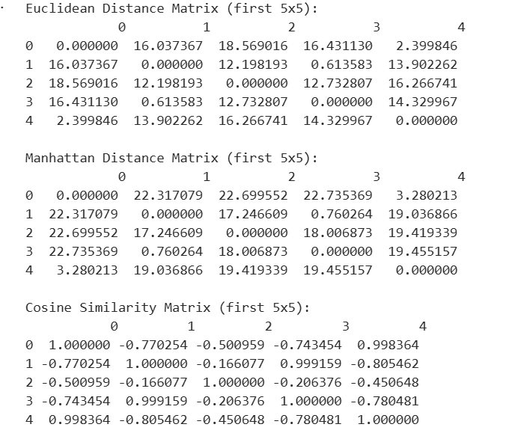
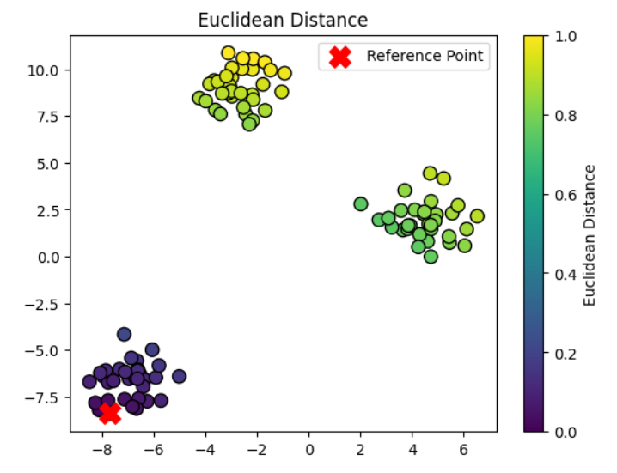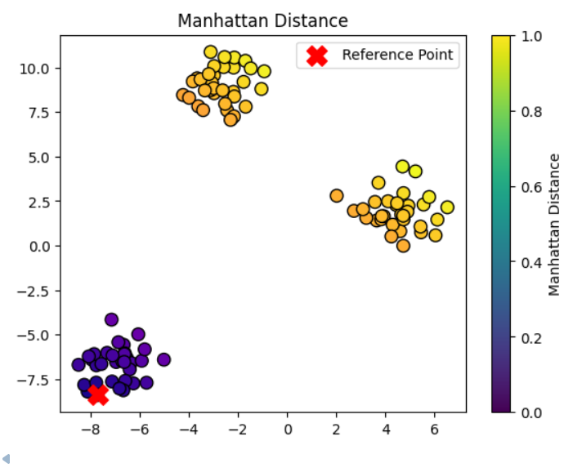
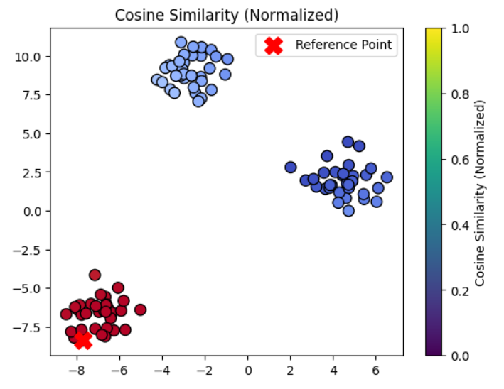
LEARNING OUTCOMES-

EXPERIMENT NO.-02
AIM-
Write a program for clustering quality comparison k-means vs EM gaussian mixture models.
BACKGROUND-
In unsupervised learning, the notion of similarity and dissimilarity plays a crucial role in grouping and analyzing unlabeled data. Since the dataset lacks predefined class labels, clustering and other unsupervised methods rely on distance metrics to measure how close or far data points are from one another.
A distance metric is a mathematical function that quantifies the dissimilarity between two vectors in a feature space. Different distance measures can capture different relationships in the data, and the choice of metric can significantly impact the results of clustering or dimensionality reduction techniques. For instance, Euclidean distance emphasizes absolute differences in space, while Manhattan distance focuses on axis-aligned differences. Cosine similarity, on the other hand, measures orientation rather than magnitude, making it useful in text or high-dimensional data.
Synthetic datasets are often used for experimentation because they allow controlled scenarios where patterns are known beforehand. By applying and visualizing various distance metrics on such data, we can better understand how these measures influence clustering outcomes and the structure of the data.
This experiment demonstrates the implementation of different distance metrics and their effect on data visualization in unsupervised learning, providing insights into when and why a particular metric should be chosen.
ALGORITHM-
1. K-Means Clustering Algorithm
- Initialize the number of clusters kkk and randomly select kkk initial centroids.
- Assign each data point to the nearest centroid using a distance metric (typically Euclidean distance).
- Update the centroids by computing the mean of all data points assigned to each cluster.
- Repeat steps 2 and 3 until convergence (centroids no longer change or maximum iterations reached).
- Output the final cluster assignments and centroids.
2. Gaussian Mixture Model (GMM) using Expectation-Maximization (EM) Algorithm
- Initialize the number of clusters kkk, mean vectors, covariance matrices, and mixing coefficients for each Gaussian component.
- Expectation (E-step): Compute the probability (responsibility) that each data point belongs to each Gaussian component.
- Maximization (M-step): Update the parameters (mean, covariance, and mixing coefficients) of each Gaussian using the responsibilities calculated in the E-step.
- Repeat steps 2 and 3 until convergence (log-likelihood stabilizes or maximum iterations reached).
- Output the final cluster assignments based on the highest probability and the Gaussian parameters.
CODE-
import numpy as np
import matplotlib.pyplot as plt
from sklearn.datasets import make_blobs
from sklearn.cluster import KMeans
from sklearn.mixture import GaussianMixture
from sklearn.metrics import silhouette_score, davies_bouldin_score

X, y_true = make_blobs(n_samples=500, centers=4, cluster_std=1.0, random_state=42)

kmeans = KMeans(n_clusters=4, random_state=42)
kmeans_labels = kmeans.fit_predict(X)

kmeans_silhouette = silhouette_score(X, kmeans_labels)
kmeans_db = davies_bouldin_score(X, kmeans_labels)
print("K-Means Silhouette Score:", kmeans_silhouette)
print("K-Means Davies-Bouldin Score:", kmeans_db)

gmm = GaussianMixture(n_components=4, random_state=42)
gmm_labels = gmm.fit_predict(X)

gmm_silhouette = silhouette_score(X, gmm_labels)
gmm_db = davies_bouldin_score(X, gmm_labels)
print("GMM Silhouette Score:", gmm_silhouette)
print("GMM Davies-Bouldin Score:", gmm_db)

fig, axs = plt.subplots(1, 2, figsize=(12, 5))

axs[0].scatter(X[:, 0], X[:, 1], c=kmeans_labels, cmap='viridis', s=50)
axs[0].scatter(kmeans.cluster_centers_[:, 0], kmeans.cluster_centers_[:, 1], color='red', marker='x', s=200)
axs[0].set_title("K-Means Clustering")

axs[1].scatter(X[:, 0], X[:, 1], c=gmm_labels, cmap='viridis', s=50)
axs[1].set_title("GMM Clustering")

plt.show()

OUTPUT-
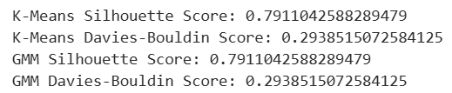
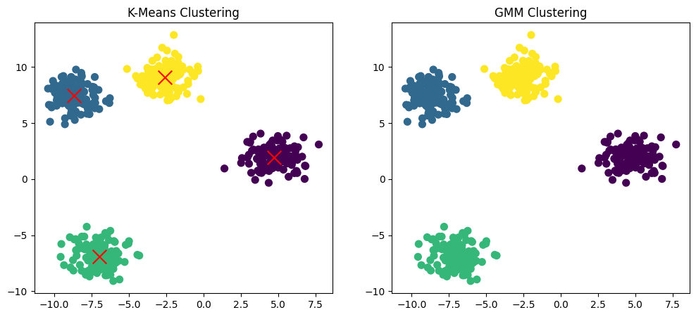

LEARNING OUTCOMES-

EXPERIMENT NO.-03
AIM-
To apply DBSCAN with hyperparameter tuning on a noisy dataset and compare its performance with K-Means.
BACKGROUND-
Clustering is an unsupervised learning technique used to group similar data points into clusters based on their characteristics. It is widely applied in fields like data mining, pattern recognition, and image analysis. Among clustering algorithms, K-Means and DBSCAN (Density-Based Spatial Clustering of Applications with Noise) are two popular approaches. Both aim to identify meaningful structures in data, but they differ significantly in methodology and performance, especially when handling noisy datasets.
K-Means is a centroid-based algorithm that partitions data into k clusters, where each cluster is represented by the mean of its points. It is efficient and performs well for spherical and evenly sized clusters. However, its main limitations are the requirement to predefine the number of clusters (k) and its sensitivity to outliers and noise, which can distort the clustering results. K Means also struggles with datasets containing clusters of irregular shapes or varying densities.
In contrast, DBSCAN is a density-based algorithm that groups points closely packed together while marking isolated points as noise. It relies on two key parameters: epsilon (ε), which defines the neighborhood radius, and minPts, the minimum number of points required to form a dense region. One of DBSCAN’s major advantages is that it does not require specifying the number of clusters beforehand and can identify clusters of arbitrary shapes. However, its performance heavily depends on the appropriate selection of ε and minPts, making hyperparameter tuning crucial for achieving optimal results.
When applied to noisy datasets, DBSCAN generally outperforms K-Means because of its ability to distinguish between dense clusters and outliers. K-Means tends to misclassify noise points into nearby clusters, while DBSCAN effectively labels them as noise. However, K-Means remains faster and more efficient for large, clean datasets. Therefore, comparing both algorithms under noisy conditions highlights the trade-off between efficiency and robustness, with DBSCAN often being the preferred choice when dealing with real-world, imperfect data.

ALGORITHM-
Step 1: Data Preprocessing
1. Import the dataset (preferably one containing noise or outliers).
2. Handle missing values, if any.
3. Normalize or standardize the data to ensure all features contribute equally to distance calculations.
4. Visualize the dataset to understand its distribution.
Step 2: Applying K-Means Clustering
1. Choose the number of clusters (k) using the Elbow Method or Silhouette Analysis.
2. Initialize k centroids randomly.
3. Assign each data point to the nearest centroid based on Euclidean distance.
4. Recalculate the centroids as the mean of all assigned points.
5. Repeat steps 3–4 until centroids stabilize (no significant change).
6. Evaluate clustering performance using metrics like Silhouette Score or Davies–Bouldin Index.
Step 3: Applying DBSCAN with Hyperparameter Tuning
- Define the range of parameters for tuning:
• ε (epsilon): neighborhood radius.
• minPts: minimum number of points to form a dense cluster.
- Use methods such as:
• k-distance plot to estimate ε (find the “elbow” point).
• Grid Search or Random Search to test multiple (ε, minPts) combinations.
- Fit the DBSCAN model using the best parameter combination.
- Identify core points, border points, and noise points.
- Evaluate cluster quality using Silhouette Score, Davies–Bouldin Index, and visual inspection.

Step 4: Performance Comparison
- Compare K-Means and DBSCAN results using:
• Number of clusters detected.
• Silhouette Score or other metrics.
• Visual cluster separation.
- Analyze the effect of noise on both algorithms.
- Conclude which algorithm performs better on noisy data — typically, DBSCAN shows superior results due to its robustness to outliers and ability to find clusters of arbitrary shapes.
CODE-
# Step 1: Import Libraries import numpy as np
import pandas as pd import matplotlib.pyplot as
plt from sklearn.datasets import make_moons from sklearn.preprocessing import StandardScaler from sklearn.cluster import KMeans, DBSCAN from sklearn.metrics import silhouette_score, davies_bouldin_score
# Step 2: Generate and Standardize Dataset
X, y = make_moons(n_samples=600, noise=0.08, random_state=42)
X_scaled = StandardScaler().fit_transform(X) plt.scatter(X_scaled[:, 0], X_scaled[:, 1], s=20, c='gray') plt.title("Noisy Dataset") plt.show()

# Step 3: Apply K-Means
kmeans = KMeans(n_clusters=2, random_state=42, n_init=10) kmeans_labels = kmeans.fit_predict(X_scaled) kmeans_silhouette = silhouette_score(X_scaled, kmeans_labels) kmeans_db = davies_bouldin_score(X_scaled, kmeans_labels)
plt.scatter(X_scaled[:, 0], X_scaled[:, 1], c=kmeans_labels, cmap='viridis', s=20) plt.title(f"K-Means Clustering\nSilhouette Score: {kmeans_silhouette:.3f}") plt.show()

print("K-Means Results") print(f"Clusters: {len(np.unique(kmeans_labels))}") print(f"Silhouette Score: {kmeans_silhouette:.3f}") print(f"Davies-Bouldin Index: {kmeans_db:.3f}") print("-" * 40)

# Step 4: DBSCAN Hyperparameter Tuning eps_values = np.arange(0.1, 0.6, 0.05) min_samples_values = [3, 4, 5, 6] best_score = -1 best_params = {} for eps in eps_values: for min_samples in min_samples_values: dbscan = DBSCAN(eps=eps, min_samples=min_samples)
labels = dbscan.fit_predict(X_scaled) if len(set(labels)) <= 1:
continue score = silhouette_score(X_scaled, labels) if score > best_score: best_score = score
best_params = {'eps': eps, 'min_samples': min_samples, 'score': score}

# Step 5: Apply Best DBSCAN Model print("Best DBSCAN Parameters:", best_params)
dbscan_best = DBSCAN(eps=best_params['eps'], min_samples=best_params['min_samples']) db_labels = dbscan_best.fit_predict(X_scaled) dbscan_silhouette = silhouette_score(X_scaled, db_labels) dbscan_db = davies_bouldin_score(X_scaled, db_labels)
plt.scatter(X_scaled[:, 0], X_scaled[:, 1], c=db_labels, cmap='plasma', s=20) plt.title(f"DBSCAN (eps={best_params['eps']}, minPts={best_params['min_samples']})\nSilhouette
Score: {dbscan_silhouette:.3f}") plt.show()
print("DBSCAN Results")
print(f"Clusters (excluding noise): {len(set(db_labels)) - (1 if -1 in db_labels else 0)}") print(f"Silhouette Score: {dbscan_silhouette:.3f}") print(f"Davies-Bouldin Index: {dbscan_db:.3f}") print("-" * 40)

# Step 6: Performance Comparison comparison = pd.DataFrame({ 'Algorithm': ['K-Means', 'DBSCAN'],
'Silhouette Score': [kmeans_silhouette, dbscan_silhouette],
'Davies-Bouldin Index': [kmeans_db, dbscan_db]
})
print("Final Comparison:") print(comparison)

OUTCOME-
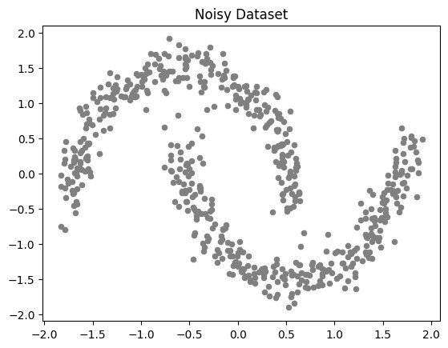
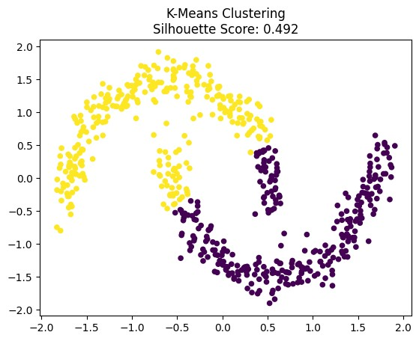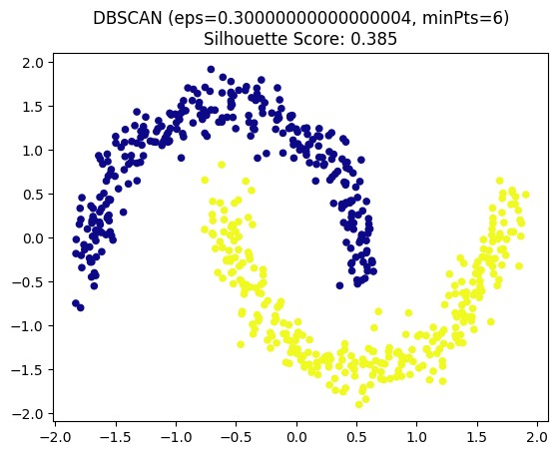

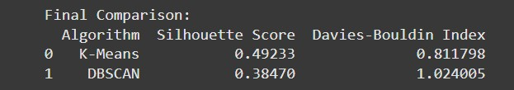
LEARNING OUTCOMES-

EXPERIMENT NO.-04

AIM-
To implement Hierarchical Clustering using Agglomerative Clustering, visualize the dendrogram with appropriate cut-off points, and compare the resulting clusters with those obtained from kMeans.

BACKGROUND-
Hierarchical clustering is an unsupervised learning technique that builds a hierarchy of clusters rather than forming them directly. It is widely used in data analysis, bioinformatics, and pattern recognition to uncover natural groupings in data without prior knowledge of the number of clusters. There are two main approaches: agglomerative (bottom-up) and divisive (top-down). In Agglomerative Clustering, each data point starts as its own cluster, and pairs of clusters are gradually merged based on similarity or distance measures until a single large cluster encompassing all data points is formed. The results are often represented through a dendrogram, which visually shows how clusters are combined step by step.
Agglomerative clustering operates using linkage criteria such as single linkage (minimum distance), complete linkage (maximum distance), average linkage, or Ward’s method (which minimizes the variance within clusters). The dendrogram serves as a crucial visualization tool, helping identify the optimal cut-off point-a horizontal line that separates the tree into distinct clusters. By observing this cut-off, one can determine the number of clusters best representing the underlying data. Unlike methods that require a predefined cluster count, hierarchical clustering allows users to explore multiple clustering levels interactively, making it particularly useful for exploratory data analysis.
To evaluate the performance of Agglomerative Clustering, it is often compared with K-Means, a centroid-based algorithm that partitions data into k clusters. While K-Means is computationally efficient and performs well for spherical, well-separated clusters, it requires specifying k in advance and is sensitive to noise and initialization. In contrast, Agglomerative Clustering can capture non-spherical structures and does not need a predefined number of clusters, but it is computationally more expensive. Comparing their results helps highlight the trade-offs between hierarchical interpretability and computational simplicity, especially in datasets with varying density or shape.

ALGORITHM-
Step 1: Data Preprocessing
- Import the dataset.
- Handle missing values, if any.
- Standardize or normalize the data to ensure uniform scaling.
- Visualize the dataset (if possible) to understand its structure.
Step 2: Implement Agglomerative Clustering
- Compute the distance matrix between all data points using an appropriate metric (e.g., Euclidean distance).
- Apply the Agglomerative Clustering algorithm:
  - Initially, treat each data point as a separate cluster. o Merge the two clusters that are closest based on the chosen linkage criterion (single, complete, average, or Ward’s).
  - Repeat merging until all points belong to a single cluster.
- Visualize the dendrogram using the linkage matrix to show the hierarchy of cluster merging.
- Determine the optimal cut-off point on the dendrogram to decide the number of clusters.
- Assign cluster labels based on the selected cut-off.
Step 3: Apply K-Means Clustering
- Use the same dataset and standardization as before.
- Choose the number of clusters (k) based on the dendrogram’s cut-off or the Elbow Method.
- Run the K-Means algorithm and assign data points to clusters.
- Visualize the K-Means clusters for comparison.
Step 4: Performance Evaluation and Comparison
- Compare the clusters obtained from both methods using metrics such as:
  - Silhouette Score - to measure cohesion and separation of clusters.
  - Davies–Bouldin Index – to evaluate cluster compactness and separation.
- Visually compare cluster boundaries or patterns in scatter plots.
- Analyze differences in cluster structure:
  - Agglomerative Clustering captures hierarchical relationships.
  - K-Means captures centroid-based partitions.
- Conclude which method performs better based on data distribution and evaluation metrics.

CODE-
# Step 1: Import Libraries import numpy as np import pandas as pd import matplotlib.pyplot as plt from sklearn.datasets import make_blobs from sklearn.preprocessing import StandardScaler from sklearn.cluster import AgglomerativeClustering, KMeans from sklearn.metrics import silhouette_score, davies_bouldin_score from scipy.cluster.hierarchy import dendrogram, linkage

# Step 2: Generate and Standardize Dataset
X, y = make_blobs(n_samples=400, centers=4, cluster_std=1.2, random_state=42)
X_scaled = StandardScaler().fit_transform(X)

plt.scatter(X_scaled[:, 0], X_scaled[:, 1], s=20, c='gray') plt.title("Original Dataset") plt.show()

# Step 3: Visualize Dendrogram linked = linkage(X_scaled, method='ward') plt.figure(figsize=(10, 5)) dendrogram(linked)
plt.title("Dendrogram for Hierarchical Clustering") plt.xlabel("Data Points") plt.ylabel("Euclidean Distance")
plt.axhline(y=6, color='r', linestyle='--') # Example cut-off line plt.show()

# Step 4: Apply Agglomerative Clustering
agg = AgglomerativeClustering(n_clusters=4, linkage='ward') agg_labels = agg.fit_predict(X_scaled)

plt.scatter(X_scaled[:, 0], X_scaled[:, 1], c=agg_labels, cmap='viridis', s=20) plt.title("Agglomerative Clustering Result") plt.show()

agg_silhouette = silhouette_score(X_scaled, agg_labels)
agg_db = davies_bouldin_score(X_scaled, agg_labels)

print("Agglomerative Clustering Results") print(f"Clusters: {len(np.unique(agg_labels))}") print(f"Silhouette Score: {agg_silhouette:.3f}") print(f"Davies-Bouldin Index: {agg_db:.3f}") print("-" * 40)

# Step 5: Apply K-Means
kmeans = KMeans(n_clusters=4, random_state=42, n_init=10) kmeans_labels = kmeans.fit_predict(X_scaled)

plt.scatter(X_scaled[:, 0], X_scaled[:, 1], c=kmeans_labels, cmap='plasma', s=20) plt.title("K-Means Clustering Result") plt.show()

kmeans_silhouette = silhouette_score(X_scaled, kmeans_labels)
kmeans_db = davies_bouldin_score(X_scaled, kmeans_labels)

print("K-Means Results")
print(f"Clusters: {len(np.unique(kmeans_labels))}") print(f"Silhouette Score: {kmeans_silhouette:.3f}") print(f"Davies-Bouldin Index: {kmeans_db:.3f}") print("-" * 40)

# Step 6: Performance Comparison comparison = pd.DataFrame({
'Algorithm': ['Agglomerative', 'K-Means'],
'Silhouette Score': [agg_silhouette, kmeans_silhouette],
'Davies-Bouldin Index': [agg_db, kmeans_db]
})

print("Final Comparison:") print(comparison)
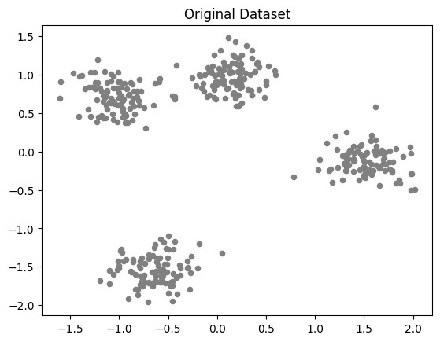

OUTCOME
-

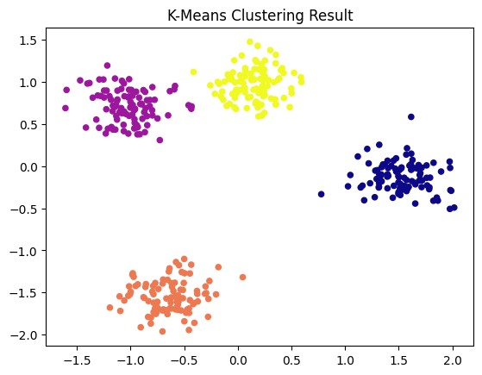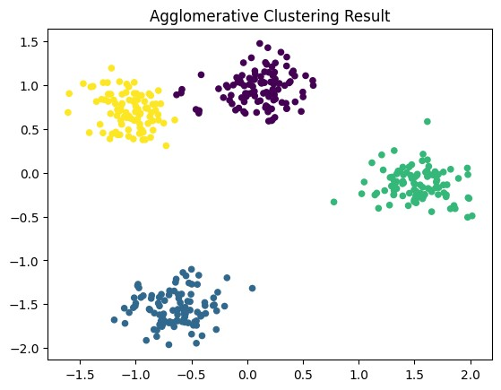

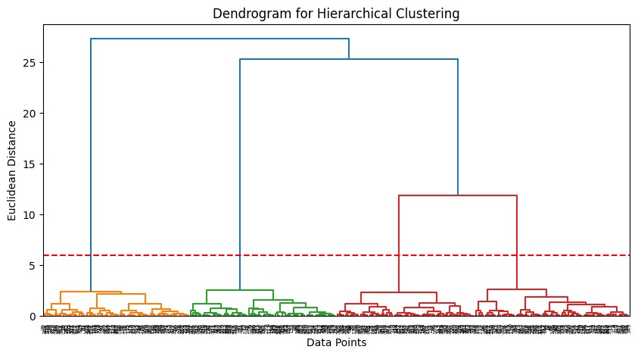

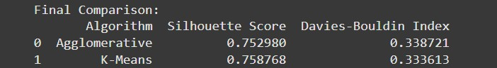

LEARNING OUTCOMES-

EXPERIMENT NO.-05

AIM-
To perform Dimensionality Reduction on the Iris dataset using Principal Component Analysis (PCA) and Linear Discriminant Analysis (LDA), and to compare their objectives and results in terms of data visualization and class separability.

BACKGROUND-
Dimensionality reduction is a technique used in machine learning to reduce the number of features in a dataset while retaining most of the important information. It is useful for visualization, reducing computational cost, and removing redundant or noisy features. Two widely used dimensionality reduction methods are Principal Component Analysis and Linear Discriminant Analysis. Both methods transform the original feature space into a lower-dimensional space, but their objectives and approaches differ.
Principal Component Analysis is an unsupervised method that finds directions, called principal components, along which the variance in the data is maximized. It does not consider class labels and aims to capture the maximum variability present in the data. PCA is commonly used for visualizing high-dimensional datasets, noise reduction, and feature extraction. By projecting the data onto the first few principal components, one can often capture most of the variability in just two or three dimensions, making it easier to visualize and interpret.
Linear Discriminant Analysis, on the other hand, is a supervised method that considers class labels while reducing dimensionality. LDA finds linear combinations of features that maximize the separation between different classes while minimizing the spread within each class. This makes it particularly useful for classification problems and for evaluating how well the classes can be separated in a lower-dimensional space. Comparing PCA and LDA on the Iris dataset helps to understand how unsupervised variance maximization differs from supervised class separability in terms of visualization and information preservation.

ALGORITHM-
Step 1: Data Preprocessing
- Load the Iris dataset.
- Separate features and class labels.
- Standardize the feature values to have zero mean and unit variance.

Step 2: Principal Component Analysis
- Compute the covariance matrix of the standardized data.
- Calculate eigenvalues and eigenvectors of the covariance matrix.
- Sort eigenvectors by decreasing eigenvalues and select the top components.
- Project the original data onto the selected principal components. • Visualize the data in the reduced dimensional space.

Step 3: Linear Discriminant Analysis
- Compute the mean vectors for each class and the overall mean.
- Calculate the within-class and between-class scatter matrices.
- Compute eigenvalues and eigenvectors of the matrix formed by the inverse of within-class scatter multiplied by between-class scatter.
- Select top eigenvectors corresponding to the largest eigenvalues.
- Project the original data onto the selected linear discriminants. • Visualize the projected data and examine class separability.

Step 4: Comparison
- Compare PCA and LDA results in terms of data visualization.
- Evaluate how well each method preserves variance and class separability. • Draw conclusions on the suitability of PCA and LDA for the dataset.

CODE-
# Step 1: Import Libraries import numpy as np import matplotlib.pyplot as plt from sklearn.datasets import load_iris from sklearn.preprocessing import StandardScaler from sklearn.decomposition import PCA
from sklearn.discriminant_analysis import LinearDiscriminantAnalysis as LDA

# Step 2: Load and Standardize Dataset
iris = load_iris() X = iris.data y = iris.target
target_names = iris.target_names
X_scaled = StandardScaler().fit_transform(X)

# Step 3: Principal Component Analysis pca = PCA(n_components=2) X_pca = pca.fit_transform(X_scaled)

plt.figure(figsize=(6,4)) for target in np.unique(y): plt.scatter(X_pca[y==target, 0], X_pca[y==target, 1], label=target_names[target]) plt.xlabel('PC1') plt.ylabel('PC2')
plt.title('PCA of Iris Dataset')
plt.legend()
plt.show()

# Step 4: Linear Discriminant Analysis lda = LDA(n_components=2) X_lda = lda.fit_transform(X_scaled, y)

plt.figure(figsize=(6,4)) for target in np.unique(y): plt.scatter(X_lda[y==target, 0], X_lda[y==target, 1], label=target_names[target]) plt.xlabel('LD1') plt.ylabel('LD2') plt.title('LDA of Iris Dataset') plt.legend()
plt.show()

# Step 5: Explained Variance for PCA explained_variance = pca.explained_variance_ratio_
print("PCA Explained Variance Ratio:", explained_variance)

# Step 6: Comparison Summary
print("PCA captures maximum variance without considering class labels.") print("LDA maximizes class separability by considering the target labels.")

OUTCOME-
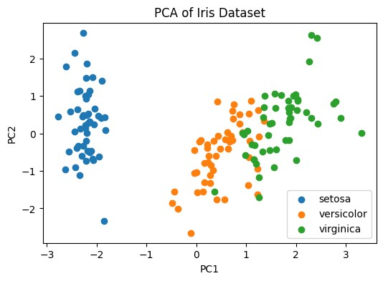
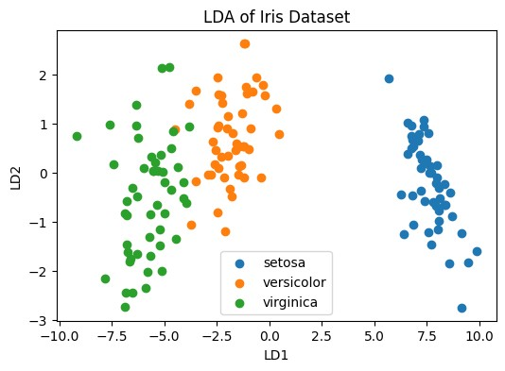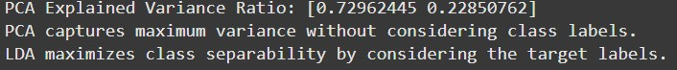

LEARNING OUTCOMES-

EXPERIMENT NO.-06

AIM-
To perform Feature Extraction on the MNIST dataset using Principal Component Analysis (PCA) and an Autoencoder, and to compare their performance in terms of reconstruction error and latent space visualization.

BACKGROUND-
Feature extraction is a process in machine learning where the most relevant information is extracted from high-dimensional data to create a more compact representation. This is particularly useful for datasets with many features, such as images, where raw pixel values can be redundant or noisy. Feature extraction reduces computational cost, improves model performance, and allows for easier visualization of the underlying data structure. Principal Component Analysis and Autoencoders are two widely used techniques for feature extraction.
Principal Component Analysis is a linear, unsupervised technique that transforms the original features into a new set of orthogonal components that capture maximum variance in the data. PCA is effective at compressing data while retaining the most significant patterns, and the lowerdimensional representation can be used for reconstruction or visualization. However, PCA is limited to capturing linear relationships and may not perform well on highly nonlinear data distributions.
Autoencoders are a type of neural network designed to learn efficient, low-dimensional representations of input data by training the network to reconstruct the input from a compressed latent space. Unlike PCA, autoencoders can capture nonlinear relationships and complex patterns in the data. Comparing PCA and autoencoders on the MNIST dataset allows evaluation of how linear and nonlinear feature extraction methods differ in terms of reconstruction error and the structure of the latent space, providing insights into the quality of the extracted features.

ALGORITHM-

Step 1: Data Preprocessing
- Load the MNIST dataset.
- Normalize pixel values to the range [0, 1].
- Flatten the images if required for PCA or feed them directly into the autoencoder.

Step 2: Principal Component Analysis • Standardize the input data.
- Compute the covariance matrix of the data.
- Calculate eigenvectors and eigenvalues of the covariance matrix.
- Select top components to form the lower-dimensional representation.
- Reconstruct the original data using the selected principal components.
- Calculate reconstruction error (e.g., mean squared error).
Step 3: Autoencoder
- Design an autoencoder neural network with an encoder and decoder.
- Train the autoencoder on the training data to minimize reconstruction error.
- Encode the data into the latent space and reconstruct it.
- Compute reconstruction error for evaluation.

Step 4: Visualization and Comparison
- Visualize the latent space of PCA and the autoencoder using scatter plots or dimensionality reduction if necessary.
- Compare reconstruction errors between PCA and the autoencoder.
- Analyze how well each method captures the underlying structure of the MNIST data.

CODE-
# Step 1: Import Libraries import numpy as np import matplotlib.pyplot as plt from sklearn.decomposition import PCA from sklearn.metrics import mean_squared_error from tensorflow.keras.datasets import mnist from tensorflow.keras.models import Model from tensorflow.keras.layers import Input, Dense
from tensorflow.keras.optimizers import Adam

# Step 2: Load and Normalize MNIST Dataset (x_train, _), (x_test, _) = mnist.load_data() x_train = x_train.astype('float32') / 255.0 x_test = x_test.astype('float32') / 255.0 x_train_flat = x_train.reshape((x_train.shape[0], -1)) x_test_flat = x_test.reshape((x_test.shape[0], -1))

# Step 3: Principal Component Analysis pca = PCA(n_components=64) x_train_pca = pca.fit_transform(x_train_flat) x_test_pca = pca.transform(x_test_flat) x_test_reconstructed = pca.inverse_transform(x_test_pca) pca_mse = mean_squared_error(x_test_flat, x_test_reconstructed) print("PCA Reconstruction MSE:", pca_mse)

plt.figure(figsize=(6,4))
plt.scatter(x_test_pca[:,0], x_test_pca[:,1], s=2, alpha=0.5) plt.title("PCA Latent Space Visualization (first 2 components)") plt.show()

# Step 4: Autoencoder input_dim = x_train_flat.shape[1] encoding_dim = 64

input_img = Input(shape=(input_dim,)) encoded = Dense(128, activation='relu')(input_img) encoded = Dense(encoding_dim, activation='relu')(encoded) decoded = Dense(128, activation='relu')(encoded)
decoded = Dense(input_dim, activation='sigmoid')(decoded)

autoencoder = Model(input_img, decoded) autoencoder.compile(optimizer=Adam(), loss='mse') autoencoder.fit(x_train_flat, x_train_flat, epochs=10, batch_size=256, validation_data=(x_test_flat, x_test_flat))

x_test_encoded = Model(input_img, encoded).predict(x_test_flat) x_test_decoded = autoencoder.predict(x_test_flat) ae_mse = mean_squared_error(x_test_flat, x_test_decoded)
print("Autoencoder Reconstruction MSE:", ae_mse)

plt.figure(figsize=(6,4)) plt.scatter(x_test_encoded[:,0], x_test_encoded[:,1], s=2, alpha=0.5) plt.title("Autoencoder Latent Space Visualization (first 2 dimensions)") plt.show()

OUTCOME-
PCA Reconstruction MSE: 0.009046790190041065
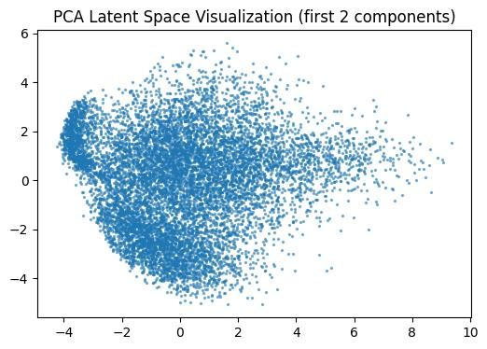

Autoencoder Reconstruction MSE: 0.007950211875140667
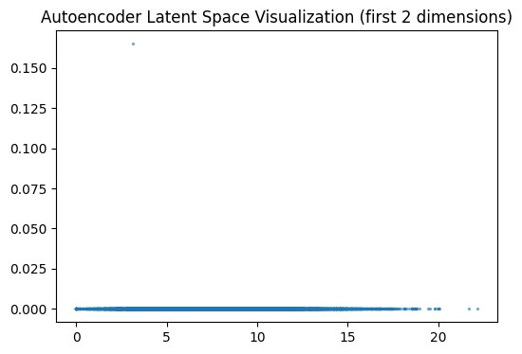

LEARNING OUTCOMES-

EXPERIMENT NO.-07

AIM-
To apply t-SNE and UMAP techniques on the MNIST dataset for high-dimensional data visualization in 2D, and to compare how effectively similar classes form distinct clusters in the reduced space.

BACKGROUND-
High-dimensional datasets, such as images, often contain complex structures that are difficult to visualize directly. Dimensionality reduction techniques are used to transform such data into a lower-dimensional space while preserving meaningful patterns and relationships. t-distributed Stochastic Neighbor Embedding (t-SNE) and Uniform Manifold Approximation and Projection (UMAP) are two widely used non-linear dimensionality reduction methods designed specifically for visualization. Both methods aim to reveal clusters and patterns in high-dimensional data when projected to two or three dimensions.
t-SNE is a probabilistic technique that converts similarities between points into joint probabilities and minimizes the divergence between these probabilities in high-dimensional and lowdimensional space. It is particularly effective at preserving local structure, which makes it useful for visualizing clusters corresponding to different classes. However, t-SNE can be computationally expensive on large datasets and may distort global structure, meaning distances between distant clusters are not always meaningful.
UMAP is a manifold learning technique based on topological and geometric principles. It preserves both local and global structure more effectively than t-SNE and is generally faster, making it suitable for larger datasets. UMAP builds a high-dimensional graph representation of the data and optimizes a low-dimensional layout to approximate this structure. Comparing t-SNE and UMAP on the MNIST dataset allows evaluation of how each method separates digits into distinct clusters, providing insights into their suitability for high-dimensional data visualization.

ALGORITHM-
Step 1: Data Preprocessing
- Load the MNIST dataset.
- Normalize pixel values to the range [0, 1].
- Flatten images if necessary for embedding algorithms.

Step 2: t-SNE
- Initialize the t-SNE model with parameters such as number of components, perplexity, and learning rate.
- Fit the t-SNE model to the high-dimensional data to obtain 2D embeddings. • Visualize the 2D embeddings, coloring points according to class labels.

Step 3: UMAP
- Initialize the UMAP model with parameters such as number of neighbors and minimum distance.
- Fit the UMAP model to the high-dimensional data to obtain 2D embeddings. • Visualize the 2D embeddings with class labels.

Step 4: Comparison
- Compare t-SNE and UMAP results visually to see how well similar classes form distinct clusters.
- Analyze the preservation of local and global structures in both embeddings.
- Draw conclusions on which technique provides better cluster separation for the MNIST dataset.

CODE-
# Step 1: Import Libraries import numpy as np import matplotlib.pyplot as plt from sklearn.datasets import fetch_openml from sklearn.preprocessing import StandardScaler from sklearn.manifold import TSNE import umap

# Step 2: Load and Normalize MNIST Dataset mnist = fetch_openml('mnist_784', version=1) X = mnist.data.astype('float32') / 255.0 y = mnist.target.astype('int')

# Optional: Use a subset for faster computation subset = 5000 X = X[:subset]
y = y[:subset]

# Step 3: t-SNE
tsne = TSNE(n_components=2, perplexity=30, learning_rate=200, random_state=42) X_tsne = tsne.fit_transform(X)

plt.figure(figsize=(6,5)) for digit in np.unique(y):
plt.scatter(X_tsne[y==digit, 0], X_tsne[y==digit, 1], s=5, alpha=0.6, label=str(digit)) plt.title("t-SNE Visualization of MNIST") plt.legend(markerscale=2) plt.show()

# Step 4: UMAP
umap_model = umap.UMAP(n_neighbors=15, min_dist=0.1, n_components=2, random_state=42)
X_umap = umap_model.fit_transform(X)

plt.figure(figsize=(6,5)) for digit in np.unique(y): plt.scatter(X_umap[y==digit, 0], X_umap[y==digit, 1], s=5, alpha=0.6, label=str(digit)) plt.title("UMAP Visualization of MNIST") plt.legend(markerscale=2) plt.show()

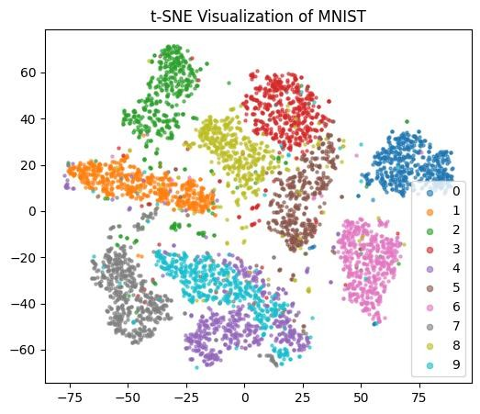
OUTCOME
-

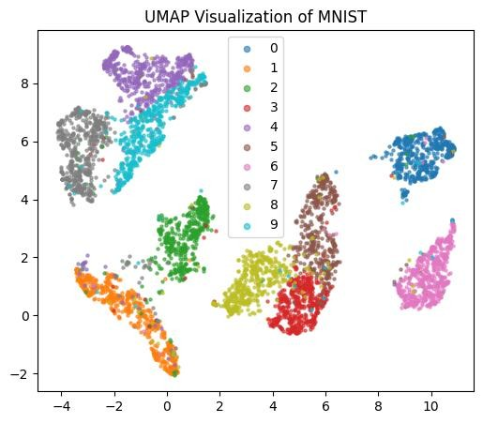

LEARNING OUTCOME
-

EXPERIMENT NO.-08

AIM-
To perform clustering of text data using TF-IDF vectorization and the k-Means algorithm, and to evaluate the effectiveness of topic separation among a set of news articles or reviews.

BACKGROUND-
Text data clustering is an unsupervised learning approach used to group documents based on similarity without prior knowledge of categories. This is useful in organizing large collections of news articles, reviews, or social media posts. One of the key challenges in text clustering is representing unstructured textual data numerically so that machine learning algorithms can process it effectively. Vectorization techniques such as Term Frequency-Inverse Document Frequency (TF-IDF) transform text into numeric vectors while emphasizing terms that are important within a document but rare across the corpus.
TF-IDF is a statistical measure that evaluates the importance of a word in a document relative to the entire dataset. It reduces the influence of common words while giving higher weight to discriminative terms. This representation allows clustering algorithms such as k-Means to group documents with similar content based on the distances between their TF-IDF vectors. K-Means is a centroid-based algorithm that partitions data into a predefined number of clusters by minimizing the sum of squared distances between points and their cluster centroids.
Evaluating clustering results in text data can be challenging due to the absence of ground truth labels in many cases. Common evaluation methods include measuring cohesion and separation of clusters using metrics like silhouette score or Davies-Bouldin index, and qualitative analysis by inspecting the top terms in each cluster. Comparing clusters generated from TF-IDF vectors with the underlying topics of articles or reviews provides insights into the effectiveness of the method in capturing meaningful patterns in textual data.

ALGORITHM-
Step 1: Data Preprocessing
- Load the text dataset (news articles, reviews, etc.).
- Clean the text by removing punctuation, numbers, and stop words. • Convert all text to lowercase.

Step 2: Feature Extraction
- Apply TF-IDF vectorization to transform text data into numeric feature vectors. • Optionally, limit the number of features to reduce dimensionality and noise.

Step 3: Clustering
- Decide on the number of clusters (k) based on prior knowledge or methods like the elbow method.
- Apply the k-Means algorithm to the TF-IDF vectors to assign each document to a cluster.

Step 4: Evaluation
- Compute clustering evaluation metrics such as silhouette score or Davies-Bouldin index.
- Inspect top terms in each cluster to qualitatively assess topic separation. • Visualize the distribution of documents among clusters if needed.

Step 5: Analysis
- Compare clusters to known topics if labels are available.
- Draw conclusions about how well the clustering captures distinct topics.

CODE-

# Step 1: Import Libraries import numpy as np import pandas as pd import matplotlib.pyplot as plt
from sklearn.feature_extraction.text import TfidfVectorizer from sklearn.cluster import KMeans
from sklearn.metrics import silhouette_score

# Step 2: Load Sample Text Data
# Example: Using a small set of news articles or reviews documents = [
"The stock market crashed due to economic slowdown",
"Investors are worried about inflation and interest rates",
"New technology products were launched at the tech conference",
"The latest smartphone model has advanced camera features",
"Economic growth has slowed down this quarter",
"The team won the championship after a tough season",
"Football and basketball tournaments are gaining popularity",
"Artificial intelligence is transforming various industries",
"New AI research papers were published in the conference",
"Sports events are attracting large audiences worldwide"
]

# Step 3: TF-IDF Vectorization
vectorizer = TfidfVectorizer(stop_words='english', max_features=50)
X_tfidf = vectorizer.fit_transform(documents)

# Step 4: K-Means Clustering
k = 3
kmeans = KMeans(n_clusters=k, random_state=42, n_init=10) labels = kmeans.fit_predict(X_tfidf)

# Step 5: Evaluation
sil_score = silhouette_score(X_tfidf, labels) print("Silhouette Score:", sil_score)

# Step 6: Top Terms in Each Cluster terms = vectorizer.get_feature_names_out() for i in range(k): cluster_center = kmeans.cluster_centers_[i] top_terms_idx = cluster_center.argsort()[::-1][:5] top_terms = [terms[idx] for idx in top_terms_idx] print(f"Cluster {i}: Top terms: {top_terms}")

# Step 7: Optional Visualization (2D via PCA) from sklearn.decomposition import PCA
X_pca = PCA(n_components=2).fit_transform(X_tfidf.toarray()) plt.figure(figsize=(6,4)) for cluster in np.unique(labels): plt.scatter(X_pca[labels==cluster,0], X_pca[labels==cluster,1], label=f"Cluster {cluster}", s=50)
plt.title("K-Means Clusters of Text Data") plt.xlabel("PC1") plt.ylabel("PC2") plt.legend()
plt.show()

OUTCOME-
Silhouette Score: 0.022813651074484027
Cluster 0: Top terms: ['new', 'conference', 'investors', 'rates', 'inflation']
Cluster 1: Top terms: ['worldwide', 'sports', 'audiences', 'attracting', 'large'] Cluster 2: Top terms: ['economic', 'quarter', 'growth', 'slowed', 'slowdown']

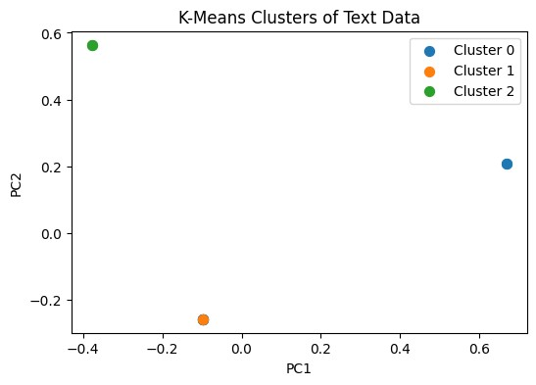

LEARNING OUTCOME-

